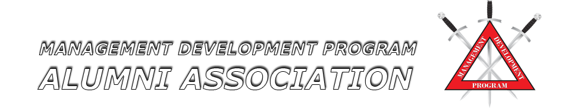

2026 Annual Conference Agenda
April 21-23, 2026
Cape Fear Community College
Wilmington, North Carolina

Tuesday, April, 21, 2026 Conference Opening & Keynote Session
8:30 a.m. – 9:00 am Registration
9:00 a.m. - 5:00 p.m. Christian Quinn, Managing Principal, Fulcrum Innovation, LLC
Topic: “The Ethical Utilization of Technology, Including Artificial Intelligence”
12:00 p.m. – 1:00 p.m. Adjourn for lunch (on your own)

Wednesday, April 22, 2026 Professional Development & Legal Considerations
9:00 a.m.-5:00 p.m. Matthew Dolan, Attorney & Director, Dolan Consulting Group
Topic: “Police Liability: Hiring, Training Supervision, and Discipline”
12:00 p.m. – 1:00 p.m. Adjourn for lunch (on your own)

Thursday, April 23, 2026 MDPAA Board Business
9:00 a.m. – 12:00 p.m. Sylva Police Department
Assistant Chief Robbie Carter & Social Worker Galadriel LaVere
Topic: “The Co-Responder Advantage: How Leaders Reduce Repeat Calls and
Improve Safety”
12:00 p.m. Adjournment of Conference



